1. **Create Table Name : Student and Exam**

**>>** 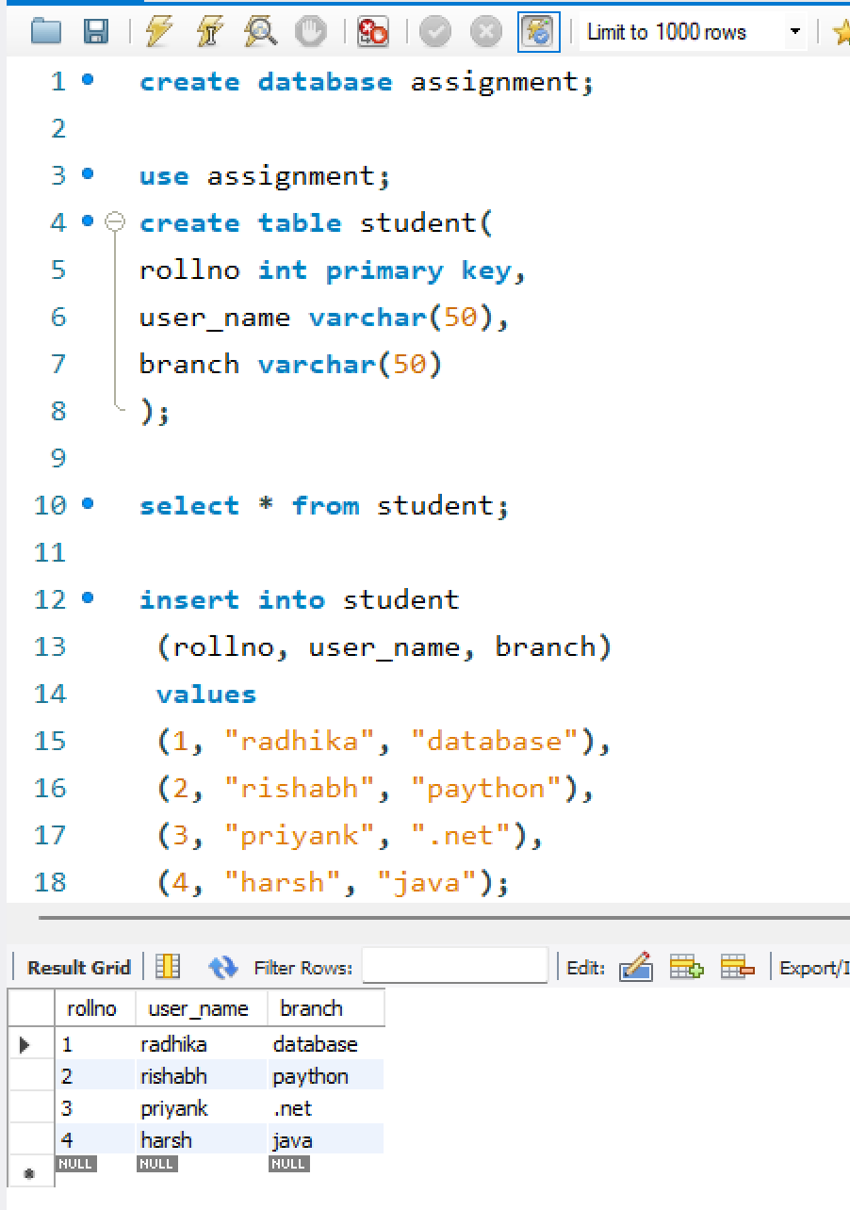

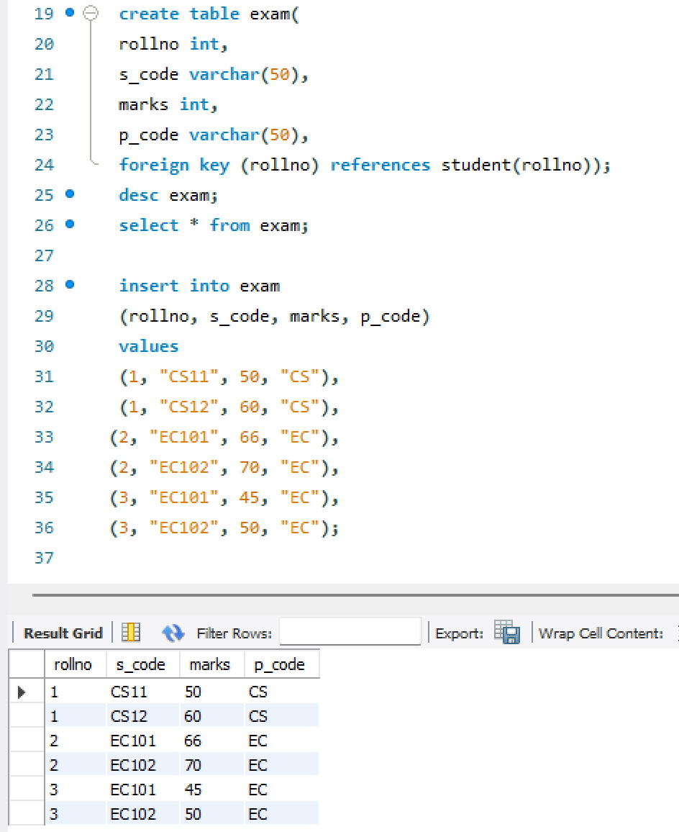

**Q2.Create table given below: Employee and IncentiveTable**

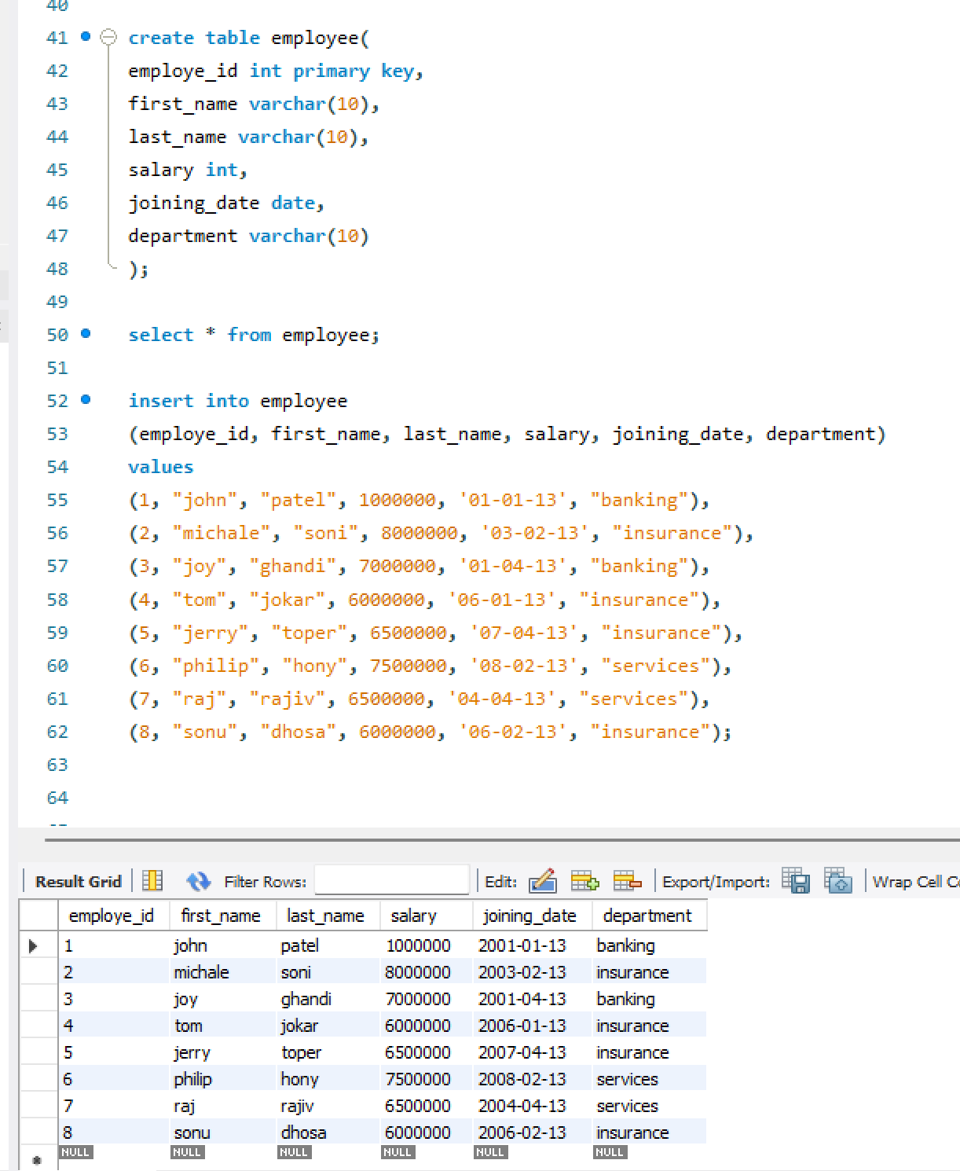

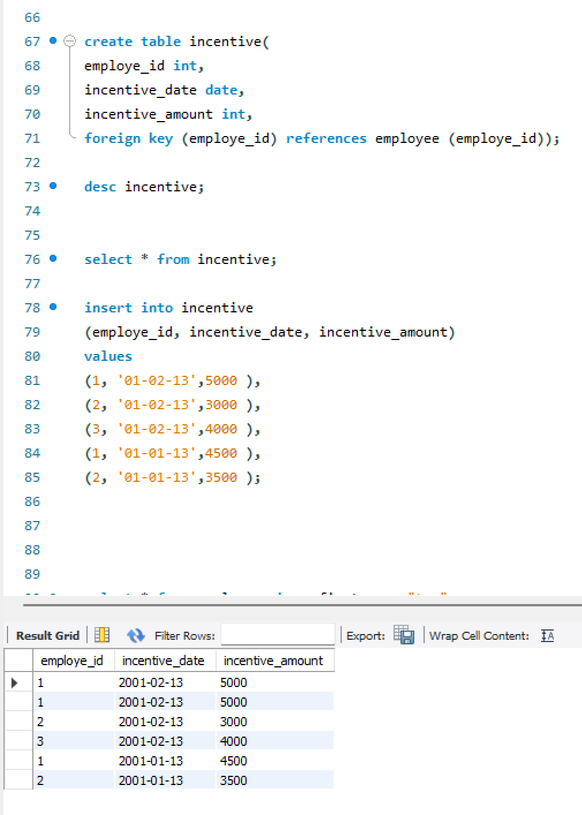

**Q3 Get First_Name from employee table using Tom name “Employee Name”.**

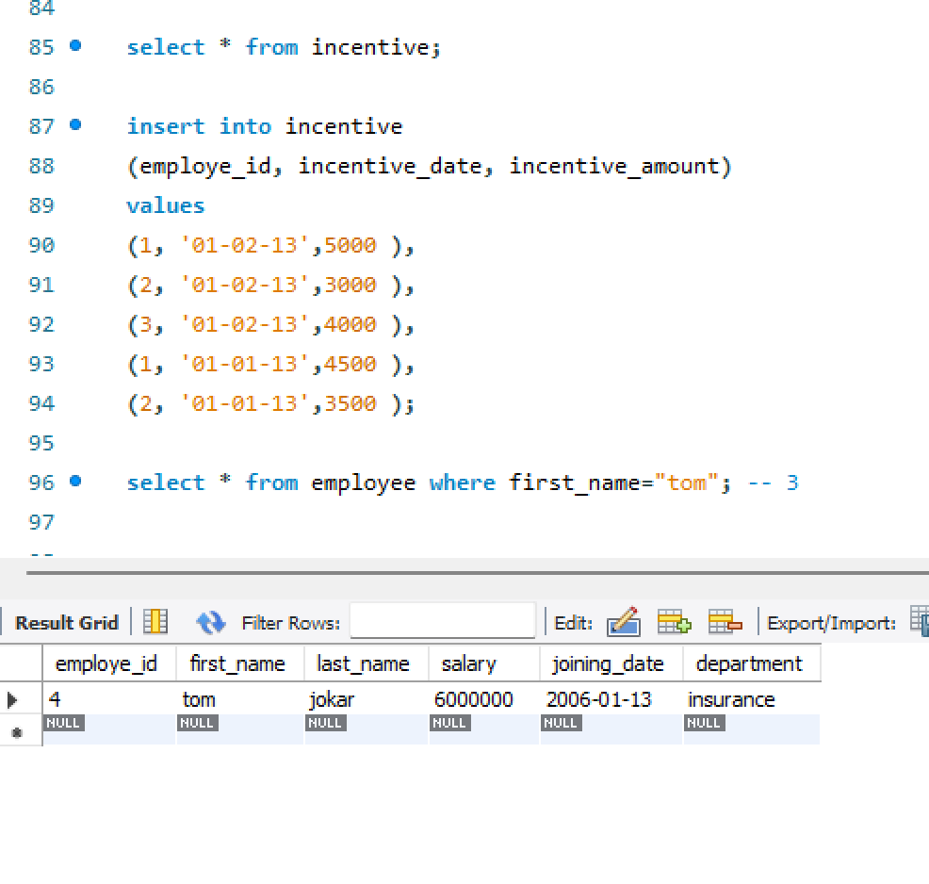

**4. Get FIRST_NAME, Joining Date, and Salary from employee table.**

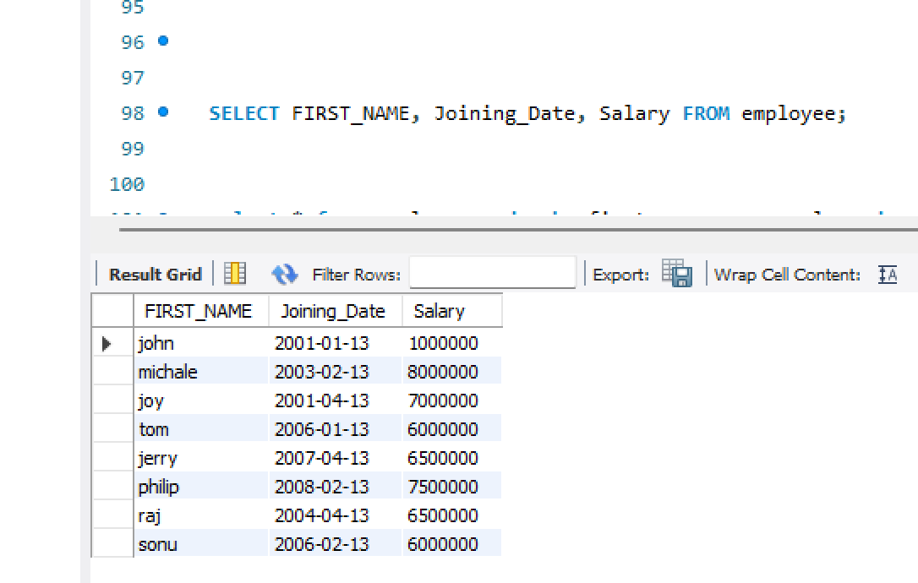

**5. Get all employee details from the employee table order by First_Name**

**Ascending and Salary descending?**

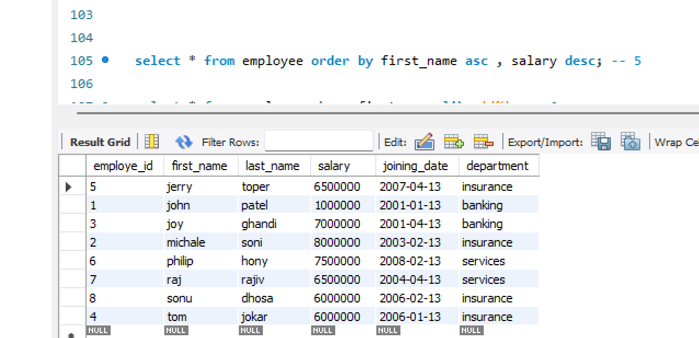

**6. Get employee details from employee table whose first name contains ‘J’.**

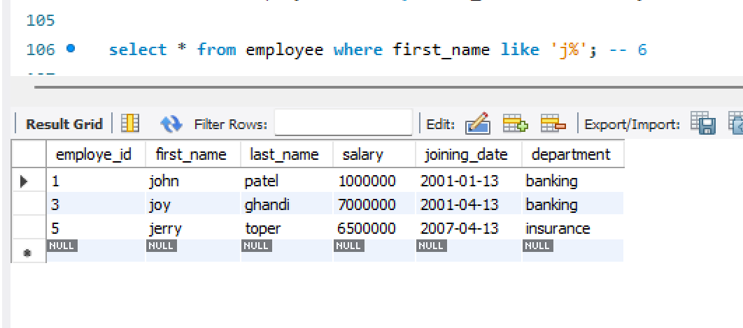

**7. Get department wise maximum salary from employee table order by salaryascending?**

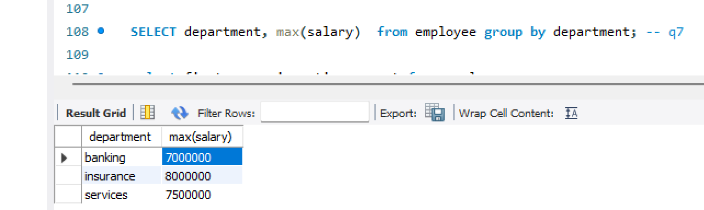

**9. Select first_name, incentive amount from employee and incentives table forthose employees who have incentives and incentive amount greater than 3000**

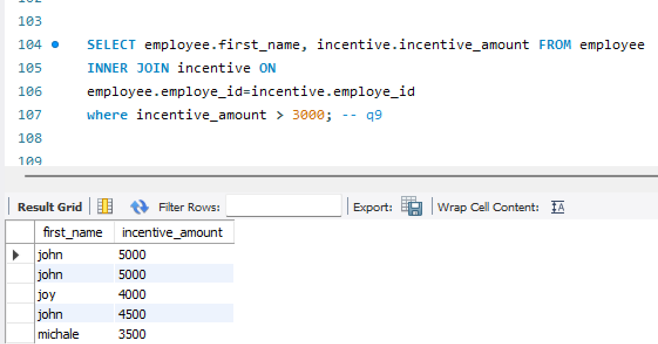

**10. Create After Insert trigger on Employee table which insert records in viewtable**

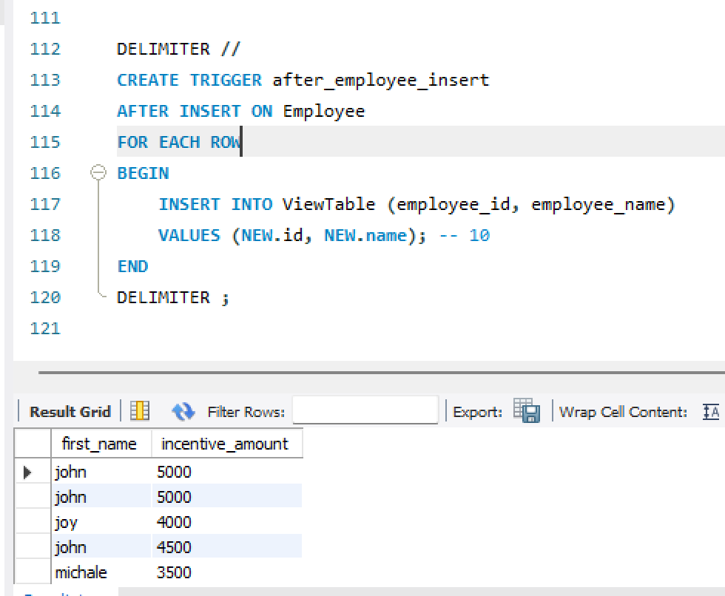

**11. Create table given below: Salesperson and Customer**

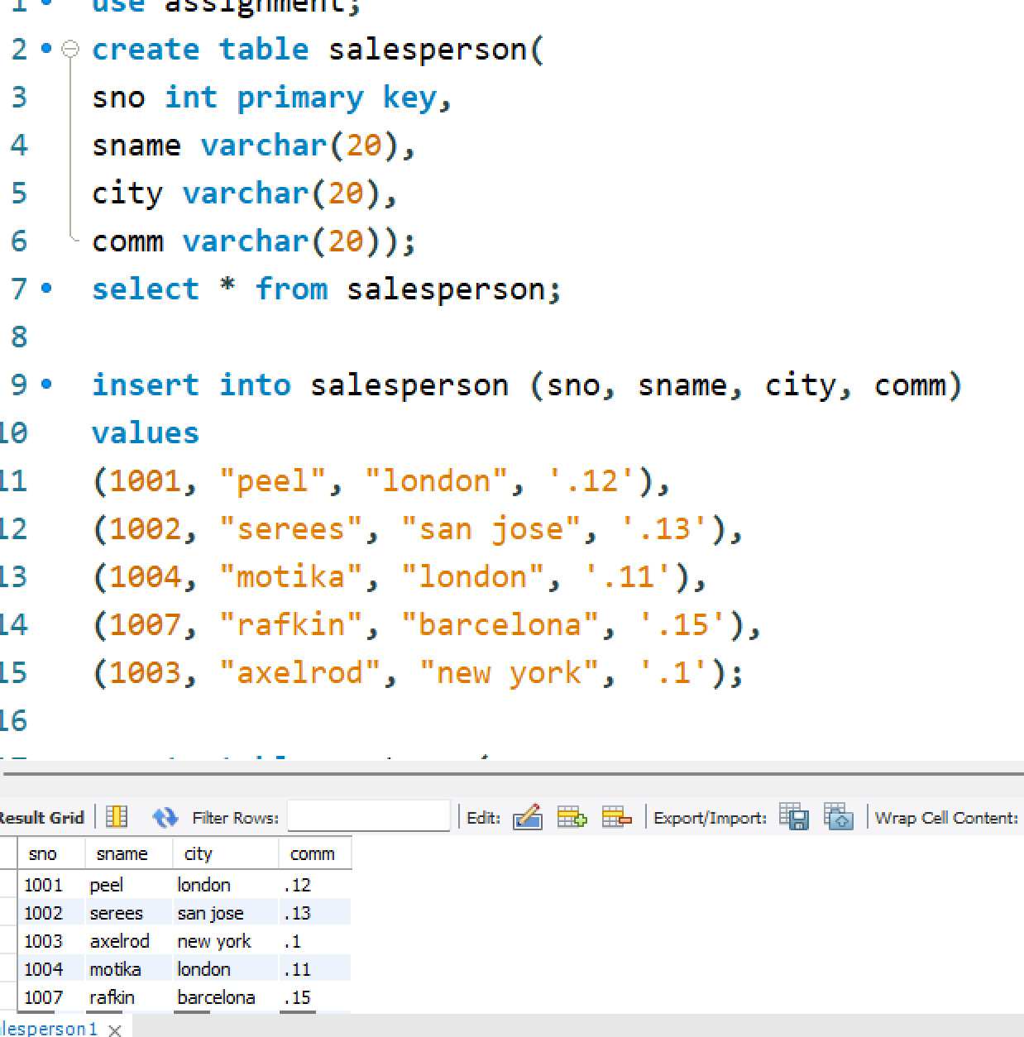

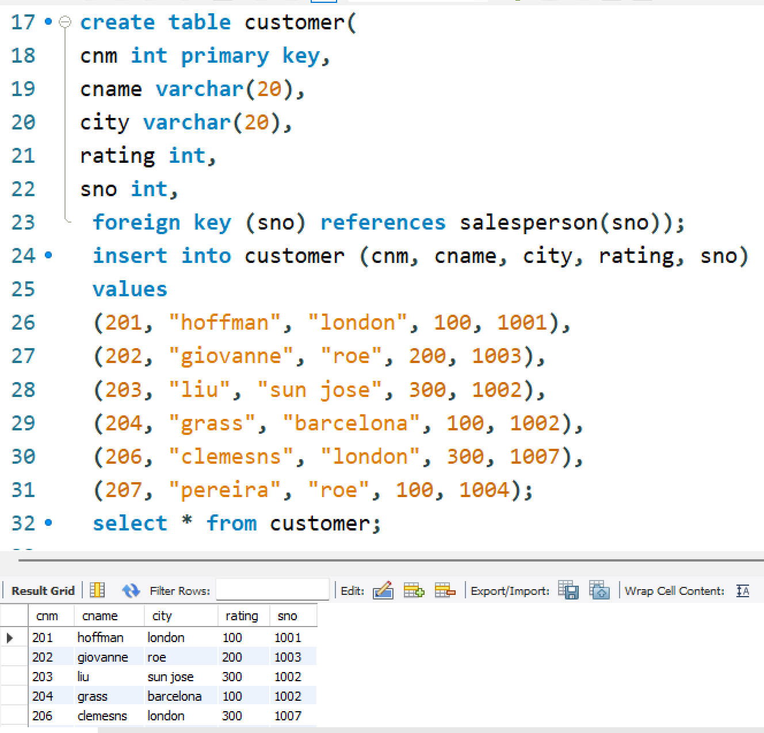

**14.Names and cities of all salespeople in London with commission above 0.12**

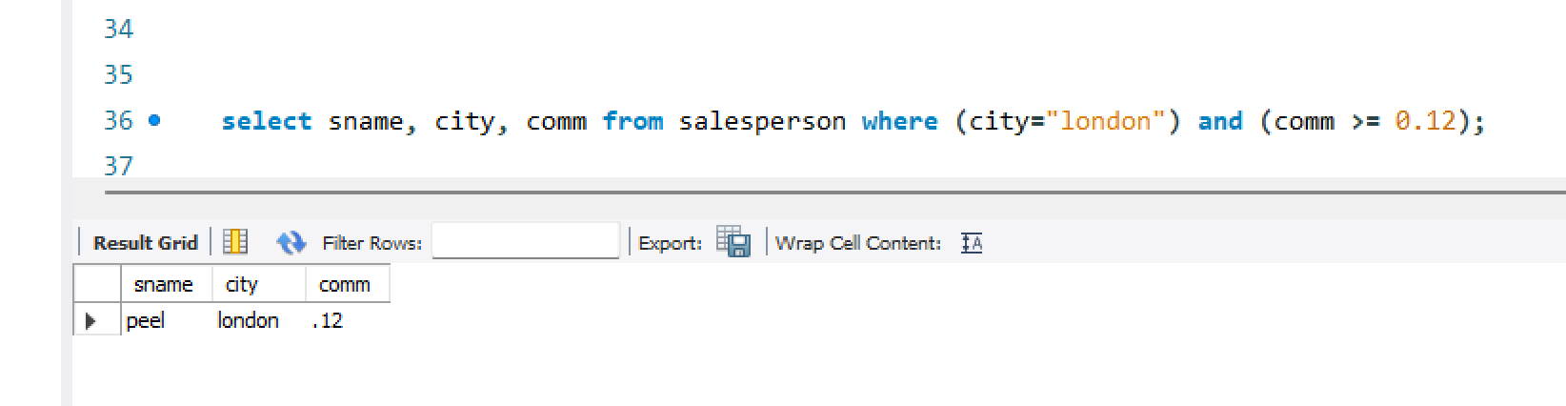

**15.All salespeople either in Barcelona or in London**

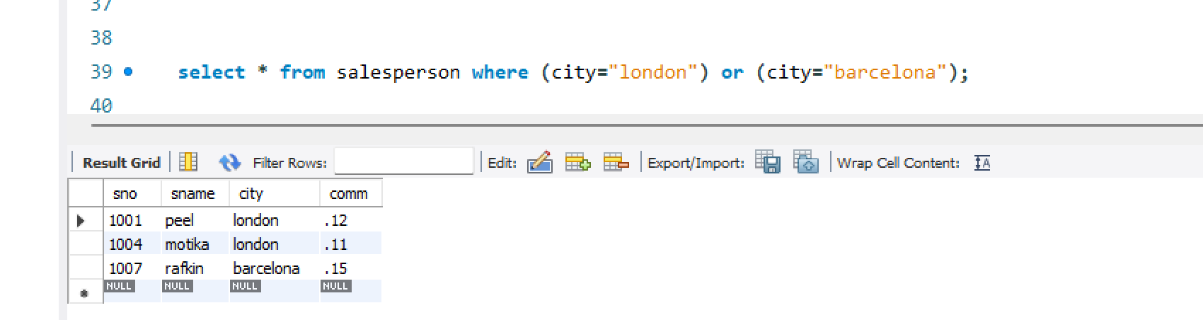

**16. All salespeople with commission between 0.10 and 0.12. (Boundary valuesshould be excluded).**

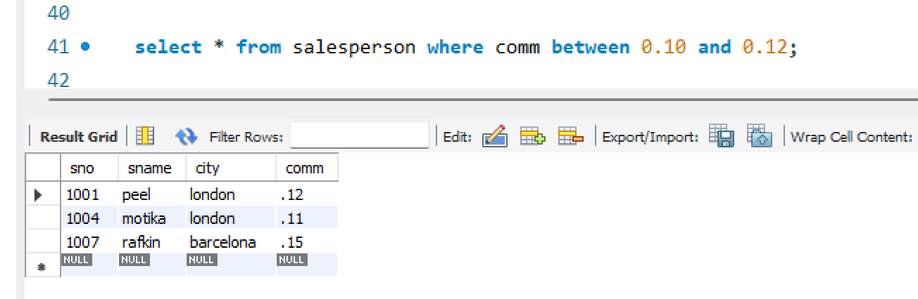

**17. All customers excluding those with rating <= 100 unless they are located inRome**

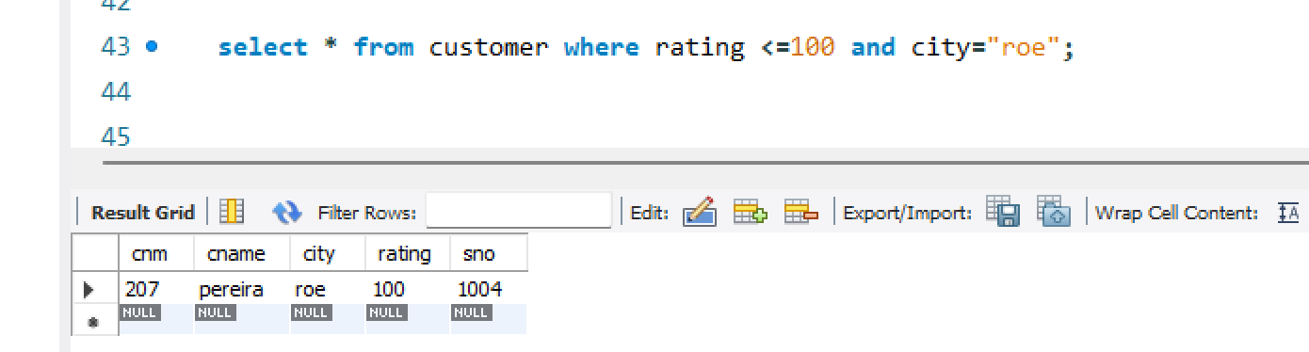

**18. Write a SQL statement that displays all the information about all salespeople**

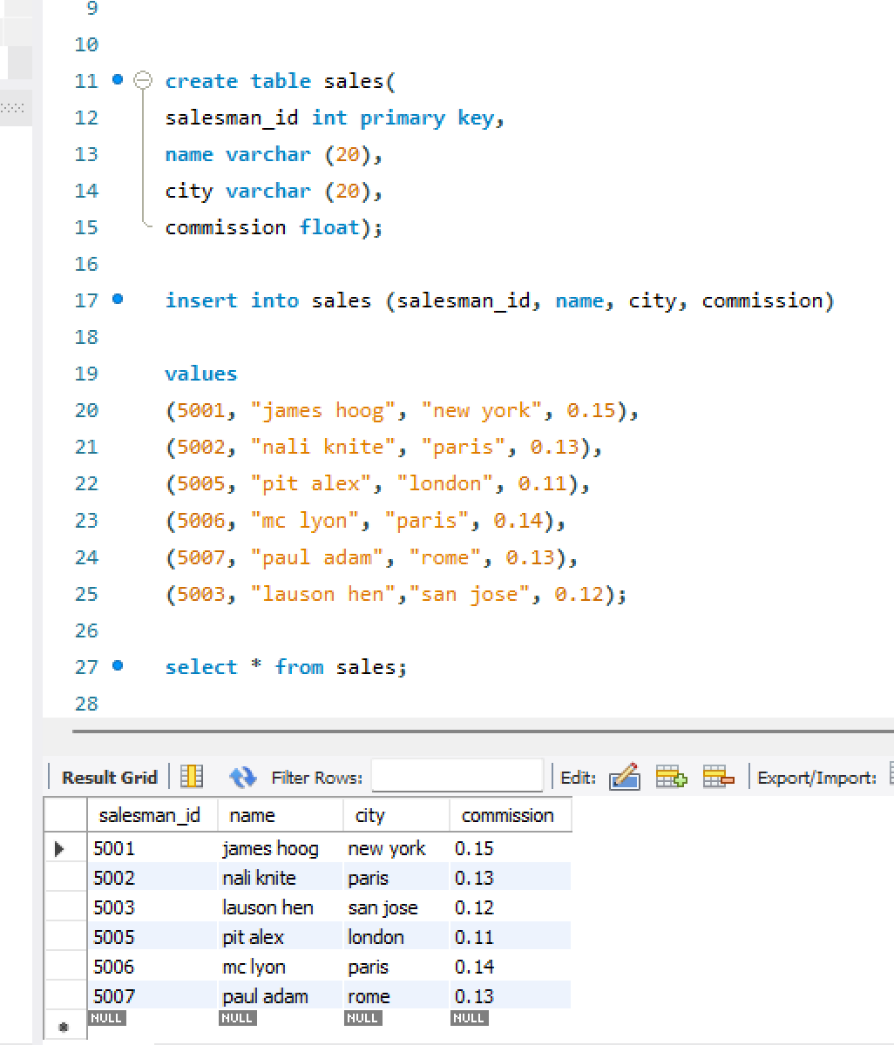

**19. From the following table, write a SQL query to find orders that are delivered by a salesperson with ID. 5001. Return ord_no, ord_date, purch_amt.**

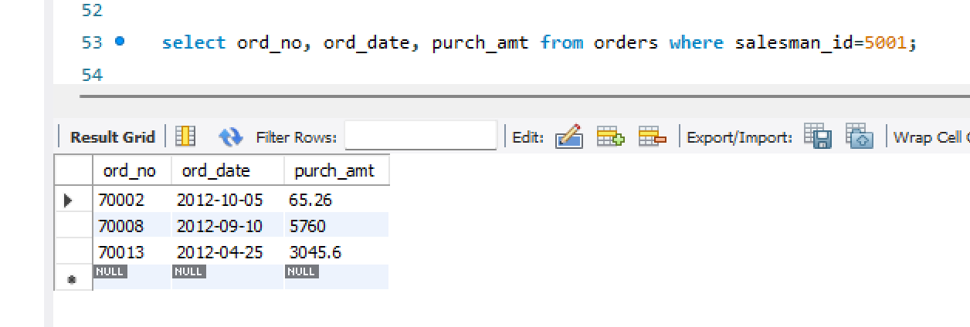

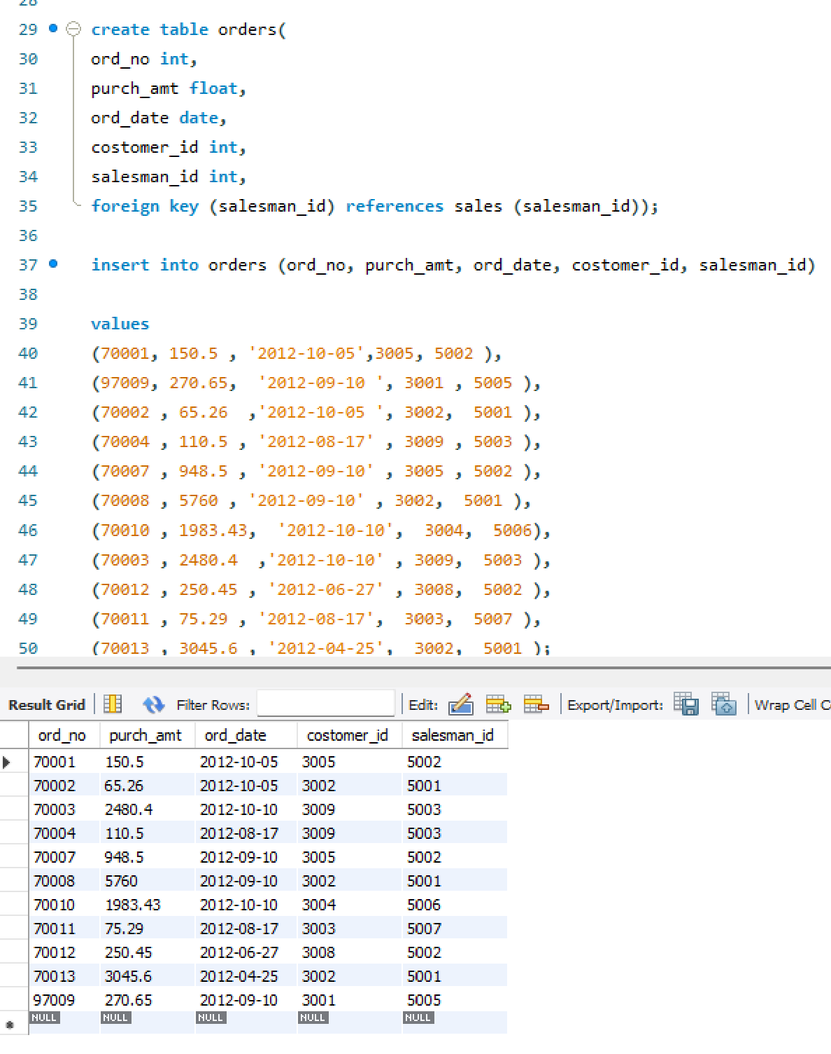

**20. From the following table, write a SQL query to select a range of products whose price is in the range Rs.200 to Rs.600. Begin and end values are included. Return pro_id, pro_name, pro_price, and pro_com.**

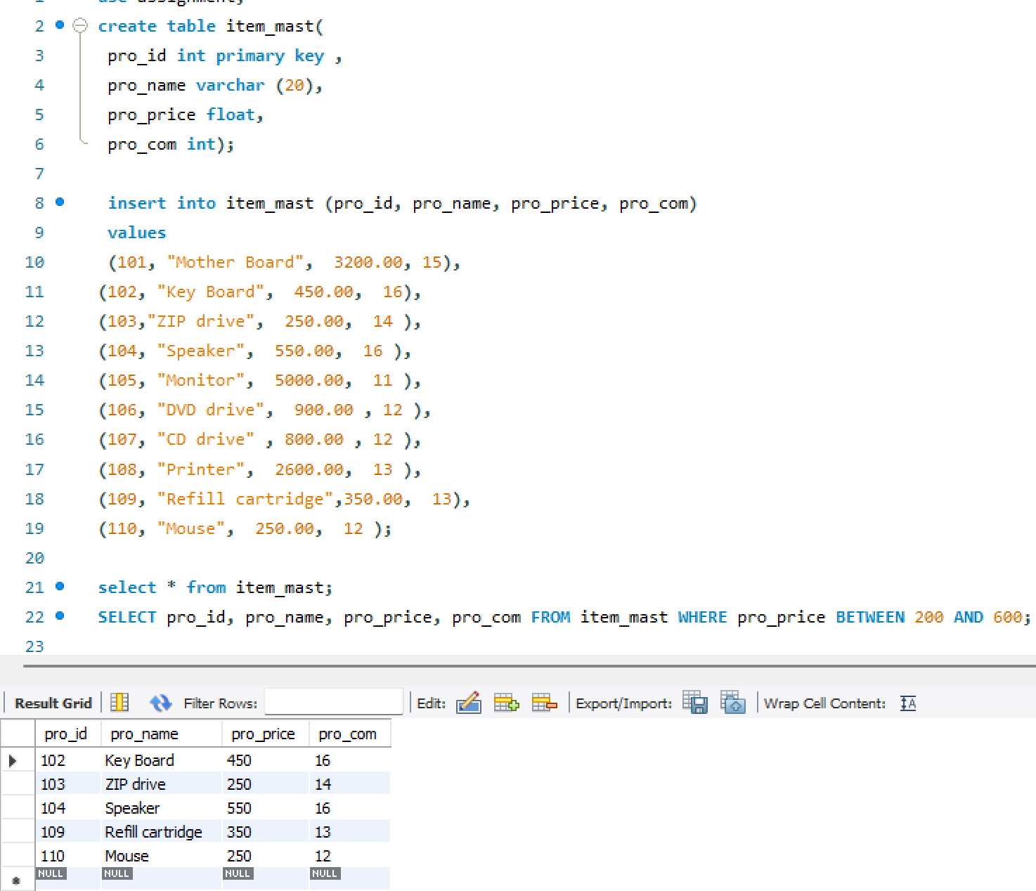

**21. From the following table, write a SQL query to calculate the average price for a manufacturer code of 16. Return avg.**

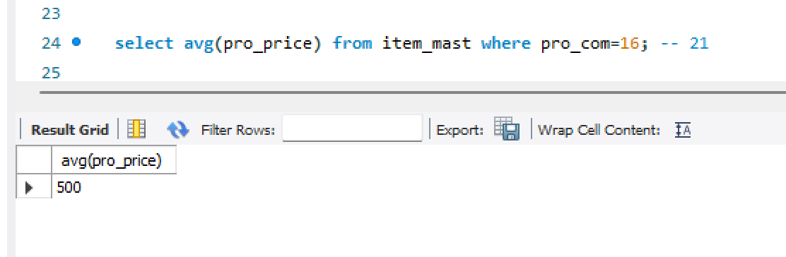

**22. From the following table, write a SQL query to display the pro_name as 'Item Name' and pro_priceas 'Price in Rs.'**

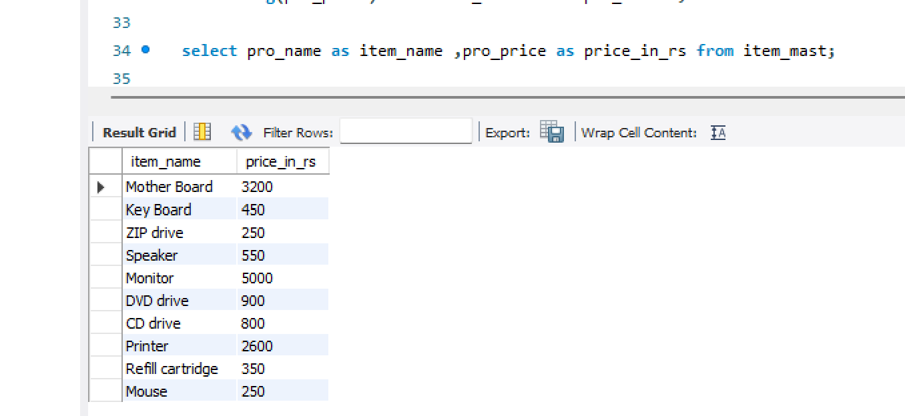

**23. From the following table, write a SQL query to find the items whose prices are higher than or equal to $250. Order the result by product price in descending, then product name in ascending. Return pro_name and pro_price.**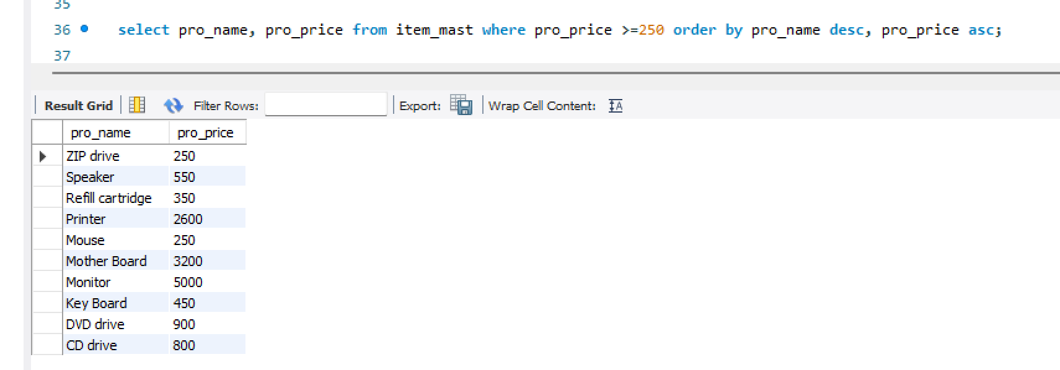

**24. From the following table, write a SQL query to calculate average price of the items for each company. Return average price and company code.**

